A Real-Time Research Project Report
on
EMBEDDED SOLAR TRACKING SYSTEM
A Smart Embedded Solution for Automatic Solar Panel Orientation and Maximum Sunlight Capture
Submitted in partial fulfillment of the requirements for the award of the degree
of
Bachelor of Technology
in
Department of CSE (Artificial Intelligence & Machine Learning)
by
A. Sai Ritish [247R1A6669]
B. Raju [247R1A6671]
Shaik Ameera Fathima [247R1A66A7]
B. Rajesh [257R5A6607]
Under the guidance of
Dr. G Vinodha Reddy
Associate Professor
DEPARTMENT OF CSE (Artificial Intelligence & Machine Learning)
CMR TECHNICAL CAMPUS
UGC AUTONOMOUS
Accredited by NBA & NAAC with ‘A’ Grade
Approved by AICTE, New Delhi and JNTU Hyderabad
Kandlakoya(V), Medchal Road, Hyderabad – 501401
April, 2026

DEPARTMENT OF CSE (AI&ML)

CERTIFICATE
This is to certify that the Real-Time Research Project Report entitled “EMBEDDED SOLAR TRACKING SYSTEM : A Smart Embedded Solution for Automatic Solar Panel Orientation and Maximum Sunlight Capture” being submitted by A. Sai Ritish [247R1A6669], B. Raju [247R1A6671], Shaik Ameera Fathima [247R1A66A7], B. Rajesh [257R5A6607] in partial fulfillment of the requirements for the award of the degree of Bachelor of Technology in CSE (Artificial Intelligence & Machine Learning) to the Jawaharlal Nehru Technological University, Hyderabad is a record of Bonafide work carried out by them under my guidance and supervision during the Academic Year 2025 – 26.
The results embodied in this report have not been submitted to any other University or Institute for the award of any other degree.

Dr. G. Vinoda Reddy Dr. S Rao Chintalapudi
Professor Head of the Department
Project Guide

ACKNOWLEDGEMENT
Apart from the efforts of us, the success of any project depends largely on the encouragement and guidelines of many others. We take this opportunity to express our gratitude to the people who have been instrumental in the successful completion of this project.
We take this opportunity to express my profound gratitude and deep regard to my guide Dr. G. Vinoda Reddy, Professor, for her exemplary guidance, monitoring and constant encouragement throughout the project work. The blessing, help and guidance given by him shall carry us a long way in the journey of life on which we are about to embark. We are also thankful to Dr. S Rao Chintalapudi, Head, Department of Computer Science and Engineering (Artificial Intelligence & Machine Learning) for providing encouragement and support for completing this project successfully.
We are obliged to Dr. A. Raji Reddy, Director for being cooperative throughout the course of this project. We also express our sincere gratitude to Sri. Ch. Gopal Reddy, Chairman for providing excellent infrastructure and a nice atmosphere throughout the course of this project. The guidance and support received from all the members of CMR Technical Campus who contributed to the completion of the project. We are grateful for their constant support and help. Finally, we would like to take this opportunity to thank our family for their constant encouragement, without which this assignment would not be completed. We sincerely acknowledge and thank all those who gave support directly and indirectly in the completion of this project.

A. Sai Ritish [247R1A6669]
B. Raju [247R1A6671]
Shaik Ameera [247R1A66A7]
B. Rajesh [257R5A6607]
ABSTRACT
The increasing demand for renewable energy has driven the need for more efficient solar power generation systems. This project presents an embedded solar tracking system designed to enhance the efficiency of solar panels by continuously aligning them with the direction of maximum sunlight. The system employs Light Dependent Resistors (LDRs) to sense variations in light intensity and an Arduino UNO microcontroller to process the acquired data. Based on the comparative analysis of sensor inputs, a servo motor is actuated to adjust the orientation of the solar panel in real time, enabling it to track the sun’s movement throughout the day. Additionally, a buzzer is incorporated for indication and alert purposes. By maintaining optimal alignment with the sun, the proposed system significantly improves energy capture efficiency when compared to conventional fixed solar panel systems.
LIST OF FIGURES
S. No | Figure Name | Page No
Figure 4.2 | Proposed Methodology | 10
Figure 4.3.1 | Class Diagram for Embedded Solar Tracking System | 12
Figure 4.3.2 | Use Case Diagram for Embedded Solar Tracking System | 13
Figure 4.3.3 | Sequence Diagram for Embedded Solar Tracking System | 14
Figure 4.3.4 | Component Diagram for Embedded Solar Tracking System | 16
Figure 4.3.5 Activity Diagram for Embedded Solar Tracking System 17
Figure 7.1 System Setup for Embedded Solar Tracking System 30
Figure 7.2 Working Output for Embedded Solar Tracking System 31

Table of Contents
Chapter Title Page No
Abstract i
List of Figures ii
1. Introduction
1.1 Motivation 1
1.2 Problem Statement 1
1.3 Project Objective 2
2. Literature Survey
2.1 Solar Tracking Systems Overview 3
2.2 Fixed vs Tracking Solar Panels 3
2.3 LDR-based Solar Tracking Systems 3
2.4 Microcontroller-based Solar Systems 4
2.5 Motor-Based panel adjustment 4
2.6 Challenges in solar tracking systems 4
3. Requirement Specification
3.1 Software Requirements 6
3.2 Hardware Requirements 6
3.3 Functional Requirements 7
3.4 Non-Functional Requirements 7
4. System Design
4.1 System Design 8
4.2 Proposed Methodology 10
4.3 UML Design 12
4.3.1 Class Diagram 12
4.3.2 Use Case Diagram 13
4.3.3 Sequence Diagram 14
4.3.4 Component Diagram 16
4.3.5 Activity Diagram 17
4.4 Technology Description 19
5. Implementation
5.1 System Implementation 20
5.2 Modules 22
5.3 Executable Code 23
6. Testing
6.1 Testing Definition 26
6.2 Test Cases 28
7. Results
7.1 System Setup 30
7.2 Working Output 31
8. Conclusion 33
9. Future Scope 34
10. References 35

1.INTRODUCTION
Rising energy demands and the decline of fossil fuels have increased the focus on clean, renewable sources like solar power. However, traditional solar panels are fixed at a set angle, preventing them from following the sun's movement throughout the day. This lack of flexibility leads to inconsistent exposure, resulting in lower energy generation and inefficient power use.
1.1 MOTIVATION
The growing demand for renewable energy has highlighted the inefficiency of fixed solar panels, which fail to track the sun's movement and waste potential power. The Embedded Solar Tracking System solves this by using sensors to automatically align panels with the brightest sunlight. By ensuring maximum exposure throughout the day, this project provides a simple, low-cost, and automated way to significantly boost solar energy production.
1.2 PROBLEM STATEMENT
Conventional solar panels are typically installed at a fixed angle and direction, which limits their ability to capture sunlight efficiently throughout the day. As the sun moves across the sky from east to west, the angle of sunlight changes continuously, resulting in reduced power generation for a significant portion of the day.
This limitation leads to inefficient utilization of available solar energy and affects the overall performance of solar power systems. In addition, manual adjustment of solar panels is not practical, especially for large-scale or continuous operation systems.

1.3 PROJECT OBJECTIVE
The primary objective of the Embedded Solar Tracking System is to enhance the efficiency of solar panels by automatically aligning them with the direction of maximum sunlight throughout the day.
Specific objectives include:
- Maximize Energy Capture: Improve solar energy absorption by continuously tracking sunlight.
- Automated Operation: Eliminate the need for manual adjustment of solar panels
- Real-Time Monitoring: Use LDR sensors to detect changes in sunlight intensity and respond instantly
- Dynamic Panel Adjustment: Control the servo motor to rotate the panel toward the brightest light source
- Improve System Efficiency: Achieve better performance compared to conventional fixed solar panels.
  - LITERATURE SURVEY
Solar tracking systems improve energy efficiency by using sensors and motors to move panels, so they always face the sun. Unlike fixed panels, these dynamic systems continuously align themselves to capture maximum sunlight. Current research aims to make this technology more accurate, reliable, and affordable for wider use. By minimizing energy loss and maximizing exposure, these trackers significantly boost the overall output of renewable power plants.
2.1 SOLAR TRACKING SYSTEMS OVERVIEW
Solar tracking systems boost energy output by moving panels to stay facing the sun throughout the day. Single-axis systems are simpler and cheaper, rotating from east to west to follow the sun's daily path. Dual-axis systems are more advanced and expensive, adjusting both horizontally and vertically to account for seasonal changes.
2.2 FIXED vs TRACKING SOLAR PANELS
Traditional solar panels are installed at a fixed angle, which is cost-effective but limits their ability to capture sunlight throughout the day. In contrast, dynamic tracking systems adjust the panel's orientation to maintain optimal alignment, potentially increasing energy efficiency by 20% to 40%.
2.3 LDR-BASED SOLAR TRACKING SYSTEMS
Light Dependent Resistors (LDRs) are popular in solar tracking systems because they are affordable, simple, and easy to implement. These sensors detect light intensity and provide analog signals that help a controller determine the sun's exact position. By comparing data from multiple sensors, the system can dynamically adjust the panel to face the brightest point in the sky. While environmental factors like shadows or dust can affect accuracy, LDRs remain the standard choice for low-cost, real-time tracking projects.
2.4 MICROCONTROLLER-BASED SOLAR SYSTEMS
Microcontrollers like the Arduino UNO serve as the brain of solar tracking systems, automatically processing sensor data to control panel movement. These platforms compare light intensity values to generate precise signals for motors, ensuring optimal alignment without human intervention.
2.5 MOTOR-BASED PANEL ADJUSTMENT
Servo motors are preferred for solar tracking due to their precise angular control and stability, whereas DC motors offer a more economical solution for larger systems. By responding to microcontroller signals, these actuators accurately adjust panel orientation to ensure the system consistently faces the sun.
2.6 CHALLENGES IN SOLAR TRACKING SYSTEMS
Despite their advantages, solar tracking systems face several challenges. One of the main challenges is increased system complexity due to the integration of sensors, controllers, and motors. This can lead to higher installation and maintenance costs.
2.7 RECENT ADVANCEMENTS IN SOLAR TRACKING
Recent advancements in solar tracking systems focus on improving efficiency and reducing system cost. Technologies such as IoT-based monitoring, smart control algorithms, and advanced sensors are being integrated into modern systems.
IoT-enabled systems allow remote monitoring and control of solar panels, improving system management and performance.
These developments indicate that solar tracking systems are evolving toward smarter, more efficient, and more reliable solutions for renewable energy applications.
2.8 CONCLUSION
The literature survey demonstrates that solar tracking systems significantly improve the efficiency of solar energy generation compared to fixed systems. The use of LDR sensors, microcontrollers, and motor-based control mechanisms provides an effective and economical solution for real-time solar tracking. Although challenges such as cost and environmental factors exist, continuous advancements in technology are addressing these issues. The reviewed studies provide a strong foundation for the development of the Embedded Solar Tracking System proposed in this project.

3.REQUIREMENTS SPECIFICATION
This chapter describes the software and hardware requirements needed for the development and implementation of the Embedded Solar Tracking System. The system is designed using embedded components to automatically track sunlight and adjust the solar panel position for maximum efficiency.
3.1 SOFTWARE REQUIREMENTS
The software requirements for the Embedded Solar Tracking System include the necessary tools for developing and controlling the hardware. The system is programmed in Embedded C using the Arduino IDE on standard operating systems like Windows, Linux, or macOS. Key software tasks include managing USB driver communication, simulating circuits in tools like TinkerCAD or Proteus, and processing sensor data to automatically adjust the motor's position.
3.2 HARDWARE REQUIREMENTS
The hardware components required for the system are:
- Arduino UNO: Acts as the main controller to process sensor data
- LDR Sensors: Detect sunlight intensity from different directions
- Servo Motor: Rotates the solar panel based on sensor input
- Solar Panel: Captures sunlight and converts it into electrical energy
- Buzzer: Provides alert or indication signals
- Power Supply: Provides necessary voltage to the system
- Connecting Wires and Breadboard: Used for circuit connections
3.3 FUNCTIONAL REQUIREMENTS
The functional requirements define the system's core operations for efficient performance. The Arduino processes real-time light intensity from LDR sensors to identify the sun's position and automatically directs the servo motor to rotate the panel. This ensures continuous, accurate tracking throughout the day, while a buzzer provides status alerts to indicate system activity.
3.4 NON-FUNCTIONAL REQUIREMENTS
The functional requirements describe the operations performed by the system:
Sunlight Detection: The system should detect light intensity using LDR sensors
Data Processing: The Arduino should read and compare sensor values
Automatic Tracking: The system should rotate the solar panel toward maximum sunlight
Motor Control: The servo motor should adjust the panel position accurately

  - SYSTEM DESIGN
4.1 System Design
In this phase, the overall design of the Embedded Solar Tracking System is developed based on the requirement specifications. The system is designed as an embedded hardware setup that automatically tracks sunlight and adjusts the orientation of the solar panel to maximize light exposure. The design focuses on simplicity, efficiency, and real-time response using low-cost components.
The system consists of sensors, a controller unit, and an actuator mechanism. The Light Dependent Resistors (LDRs) act as input devices, the Arduino UNO serves as the processing unit, and the servo motor function as the output actuator.
There are two kinds of design documents developed in this phase:
1. Architecture Overview
The architecture of the Embedded Solar Tracking System is divided into three main sections:
Input Unit (Sensors)
The input unit consists of LDR sensors placed at different positions to detect sunlight intensity. These sensors measure the amount of light falling on them and produce corresponding analog signals. When sunlight falls unevenly on the sensors, a difference in light intensity is generated. This difference is used to determine the direction in which the solar panel should rotate.
Processing Unit (Controller)
The processing unit is the Arduino UNO microcontroller, which acts as the brain of the system. It receives analog signals from the LDR sensors and converts them into digital values.
The controller compares the sensor values and determines the direction of maximum sunlight. Based on this comparison, it generates appropriate control signals for the servo motor.
Output Unit (Actuator)
The output unit consists of a servo motor connected to the solar panel. The motor receives control signals from the Arduino and rotates the panel accordingly.
The servo motor provides precise angular movement, allowing accurate alignment of the panel with the sun. This ensures that the panel always faces the direction of maximum sunlight.
Power Supply Unit
The system is powered using an external power adapter connected to the Arduino board. The Arduino distributes power to the sensors and motor.
2. System Working Design
The system operates based on a continuous feedback mechanism. The LDR sensors detect sunlight intensity and send signals to the Arduino. The controller processes this data and determines the direction of maximum light.
If there is a difference in light intensity between sensors, the Arduino sends signals to the servo motor to rotate the panel. The motor adjusts the panel position until both sensors receive equal light intensity, indicating optimal alignment.
3. Hardware Design Description
The hardware design consists of the following components connected on a base platform:
- Solar panel mounted on a movable structure
- LDR sensors fixed on small boards for light detection
- Arduino UNO connected through jumper wires
The components are arranged in such a way that the sensors can effectively detect light differences and the motor can rotate the panel smoothly.
4. Design Considerations
While designing the system, the following factors are considered:
- Accuracy: Ensuring correct detection of sunlight direction
- Response Time: Quick adjustment of panel position
- Simplicity: Using minimal and low-cost components
- Reliability: Stable operation under varying light conditions
4.2 PROPOSED METHODOLOGY
“The proposed methodology is based on real-time detection of sunlight using LDR sensors. The Arduino UNO processes the sensor values and determines the direction of maximum light intensity. Based on this, the servo motor rotates the solar panel to align with the sun. This process continues dynamically throughout the day to ensure maximum solar energy capture. A buzzer is used to indicate system activity.”

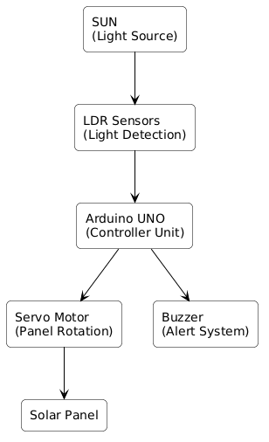
4.3 UML DESIGN
Unified Modelling Language (UML) is used to represent the structure and behaviour of the Embedded Solar Tracking System. The following diagrams help in visualizing the system components and their interactions, providing a clear understanding of the overall system design.
    - CLASS DIAGRAM
The class diagram represents the main components and their relationships within the Embedded Solar Tracking System. It includes key classes such as:
Solar Tracking System: Manages the overall system operation.
Controller: Processes sensor data and controls system functions.
LDR Sensor: Detects sunlight intensity.
Servo Motor: Rotates the solar panel.
Solar Panel: Aligns with maximum sunlight.
Buzzer: Indicates system status.

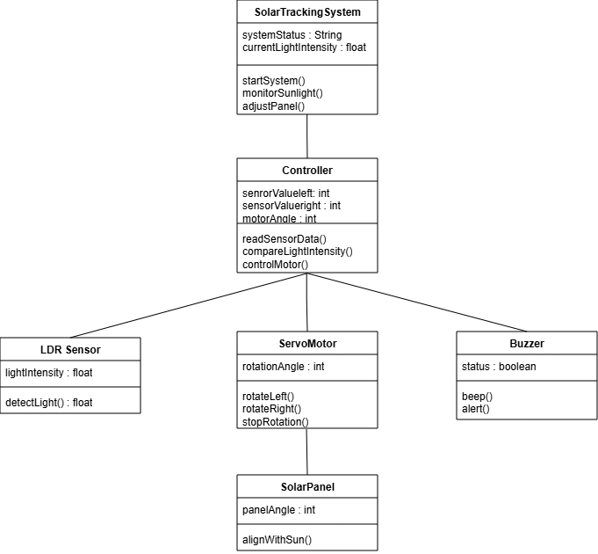
Fig 4.3.1 class diagram
4.3.2 USE CASE DIAGRAM
A Use Case Diagram shows how the user interacts with the system. In the Embedded Solar Tracking System, the user can start, monitor, and stop the system. The system automatically tracks sunlight, detects light intensity, and rotates the solar panel.
This diagram helps to understand what the system does and how the user uses it in a simple and clear way.
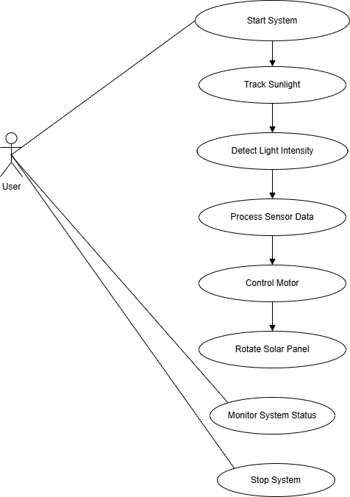
Fig 4.3.2 use-case diagram
4.3.3 COMPONENT DIAGRAM
This diagram represents the main components of the Embedded Solar Tracking System and their interactions. Key components include:
Power Supply (5V): Provides power to all components in the system.
LDR Sensors (Left & Right): Detect the intensity of sunlight.
Arduino UNO Controller: Processes sensor data and controls the system.
Servo Motor: Rotates the solar panel based on light direction.
Solar Panel: Adjusts its position to receive maximum sunlight.
Buzzer: Indicates system activity and status.
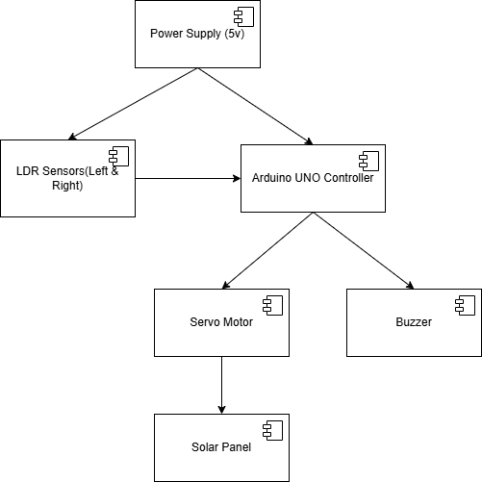
Fig 4.3.3: component diagram
4.3.4 SEQUENCE DIAGRAM
The Sequence Diagram outlines the step-by-step operation of the Solar Tracking System, from activation to shutdown. When the user starts the system, the Arduino controller triggers a buzzer and begins reading light intensity from the LDR sensors to locate the sun. The controller then signals the servo motor to rotate the panel into the optimal position while the user monitors the status. To finish, stopping the system halts the motor and activates the buzzer to confirm the power-off.
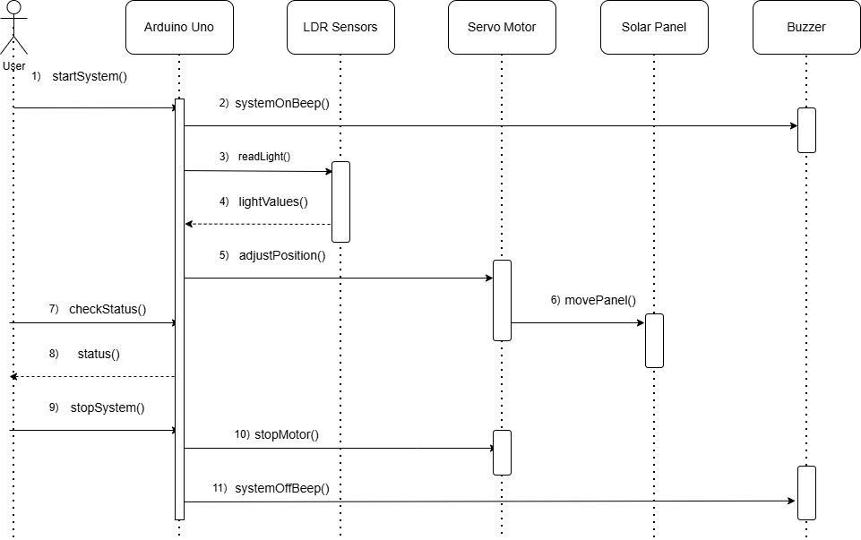
Fig 4.3.4: Sequence Diagram

4.3.5 ACTIVITY DIAGRAM
The Activity Diagram represents the workflow of the Embedded Solar Tracking System and shows how the system operates step by step. It provides a clear view of the sequence of activities involved in tracking sunlight and adjusting the solar panel position.
The process begins with starting the system, after which the system reads light intensity from the LDR sensors. The controller then compares the light values to determine the direction of maximum sunlight. Based on this comparison, the system rotates the solar panel either to the left or right, or stops the motor if the light intensity is equal.
After adjusting the panel position, the system updates its status and continues monitoring its operation. Finally, the process ends when the system stops. This diagram helps in understanding the flow of operations and decision-making within the system.
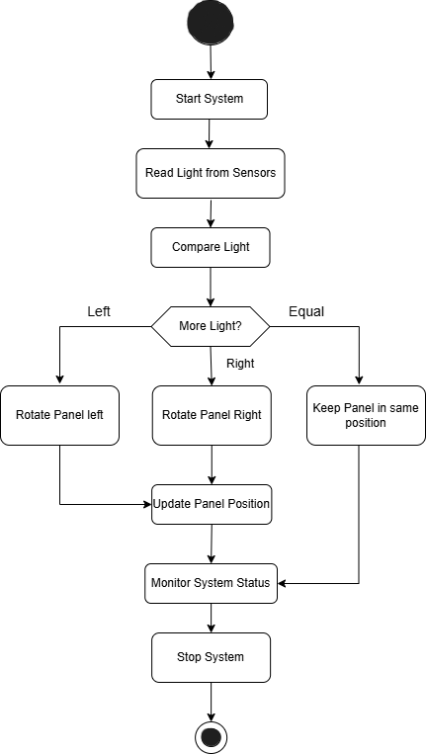
Fig 4.3.5: Activity Diagram
4.4 Technology Description
The Embedded Solar Tracking System uses a combination of hardware and embedded technologies to achieve efficient and automatic solar panel alignment. The system is designed to be simple, cost-effective, and reliable for real-time solar tracking applications.
Microcontroller:
The system uses an Arduino UNO, which acts as the main controller. It processes the input from sensors and controls the output devices based on the logic programmed.
Sensors:
LDR (Light Dependent Resistor) Sensors are used to detect the intensity of sunlight. These sensors provide analog input to the Arduino, helping it determine the direction of maximum light.
Actuator:
A Servo Motor is used to rotate the solar panel. Based on the signals from the Arduino, the motor adjusts the panel position to align with the sunlight.
PowerSupply:
A regulated 5V power supply is used to provide power to the Arduino, sensors, motor, and buzzer for smooth operation.
Programming:
The system is programmed using the Arduino IDE with Embedded C/C++.

5. IMPLEMENTATION
5.1 SYSTEM IMPLEMENTATION
The implementation phase focuses on developing the Embedded Solar Tracking System by assembling the hardware components and programming the system according to the design specifications. This phase ensures that all components such as sensors, controller, and actuator work together efficiently to achieve automatic solar tracking. The system is designed to operate in real time, continuously adjusting the solar panel position based on sunlight intensity.
Hardware Setup
The system is built using an Arduino UNO microcontroller, which acts as the central processing unit. LDR sensors are placed strategically to detect sunlight intensity from different directions. A servo motor is connected to the solar panel to enable rotational movement. A buzzer is also included to provide system indication. All components are connected using jumper wires and a breadboard, and a regulated power supply is used to ensure stable operation of the system.
Software Development
The control logic is implemented using Embedded C programming in the Arduino IDE. The program continuously reads analog values from the LDR sensors and processes them to determine the direction of maximum sunlight. Based on this analysis, control signals are sent to the servo motor to adjust the panel position. The software is designed to operate continuously without manual intervention, ensuring real-time tracking.
Sensor Data Processing
The LDR sensors generate analog signals corresponding to the intensity of light falling on them. These signals are read by the Arduino and converted into digital values. The system compares the values from multiple sensors to determine the direction of higher light intensity.
SystemOperation
The system operates on a continuous feedback mechanism. When the system is powered on, the sensors begin detecting sunlight intensity. The Arduino processes this data and identifies the direction of maximum light. The servo motor then rotates the solar panel toward that direction.
Integration and Testing
After assembling all components, the system is tested to ensure proper integration. Individual components such as sensors and motors are first tested separately. After integration, the complete system is tested under different lighting conditions to verify its performance.
Deployment
The system is deployed in a practical environment where it can receive adequate sunlight. The solar panel is mounted on a movable structure connected to the servo motor. The sensors are positioned to effectively detect light variations.
Evaluation and Optimization
After deployment, the system is evaluated under various environmental conditions such as different times of the day and varying light intensities. Performance is analyzed based on responsiveness, accuracy, and stability. Minor adjustments are made in sensor positioning and control logic to improve tracking efficiency.
5.2 MODULES
The Embedded Solar Tracking System is divided into several modules, each responsible for specific functions. These modules work together to ensure smooth and efficient operation of the system:
SensorModule
This module uses LDR sensors to detect sunlight intensity from different directions. It continuously senses light levels and sends signals to the controller.
ControlModule
The Arduino UNO acts as the control unit. It processes sensor data and compares light intensity to decide the direction in which the solar panel should rotate.
MotorControlModule
This module controls the servo motor. Based on signals from the controller, the motor rotates the solar panel toward maximum sunlight.
Solar PanelModule
This module represents the solar panel mounted on a movable structure. It rotates according to the motor’s movement to capture maximum sunlight.
Indication Module
This module includes a buzzer that provides alerts about system activity, such as system start or operation status.
Control Algorithm
The system compares light values from LDR sensors to find the direction of maximum sunlight. Based on this, it generates signals to control the motor and adjust the panel.
System Operation Module
This module manages the continuous working of the system. It ensures real-time data flow from sensors to the controller and then to the motor. The system continuously monitors light changes and adjusts the panel position automatically.
Deployment Module
This module focuses on setting up the system in a real environment. It includes mounting the solar panel, placing sensors correctly, and connecting all components. A regulated power supply is used to ensure stable operation.
Evaluation Module
This module evaluates the performance of the system. The system is tested under different light conditions to check its response and accuracy. Factors like tracking speed, alignment accuracy, and stability are observed.
5.3 EXECUTABLE CODE
#include <Servo.h>// Pin connections
int LDR_Left = A0; // Left LDR sensor
int LDR_Right = A1; // Right LDR sensor
int buzzer = 8; // Buzzer pin
Servo motor;
int pos = 90; // Initial position (center)
int threshold = 50; // Sensitivity (adjust if needed)
void setup() {
motor.attach(9); // Servo connected to pin 9
pinMode(buzzer, OUTPUT);
motor.write(pos); }
void loop() {
int leftValue = analogRead(LDR_Left);
int rightValue = analogRead(LDR_Right);
int diff = leftValue - rightValue;
// If left side has more light
if (diff > threshold) {
pos++;
if (pos > 180) pos = 180;
motor.write(pos);
digitalWrite(buzzer, HIGH);
delay(100);
digitalWrite(buzzer, LOW); }
// If right side has more light
else if (diff < -threshold) {
pos--;
if (pos < 0) pos = 0;
motor.write(pos);
digitalWrite(buzzer, HIGH);
delay(100);
digitalWrite(buzzer, LOW);}
// If both are equal (stable)
else {
digitalWrite(buzzer, LOW); }
delay(200); }
EXPLANATION
The program continuously reads analog signals from two LDR sensors placed on either side of the solar panel to measure light intensity. These values are compared to determine which side receives more sunlight. A threshold value is used to ignore minor variations and avoid unnecessary movements caused by noise or fluctuations. Based on this comparison, the Arduino identifies the direction of maximum light.
The controller then incrementally adjusts the position of the servo motor, which rotates the solar panel toward the brighter side. This process runs continuously in a loop, allowing real-time tracking of the sun’s movement throughout the day.
6. TESTING
6.1 TESTING DEFINITION
The purpose of testing is to identify errors and ensure that the system works correctly. It helps verify both individual components and the complete system. In the Embedded Solar Tracking System, testing ensures that all components function properly and the system responds accurately to changes in sunlight under different conditions.
UNIT TESTING
Unit testing is used to check individual components of the system separately before integration. Each part is tested to ensure it works correctly.
LDR Sensor Testing: Checks if sensors detect light intensity properly.
Servo Motor Testing: Ensures the motor rotates correctly based on Arduino signals.
Buzzer Testing: Verifies that the buzzer gives proper indications.
Controller Testing: Confirms that the Arduino reads data and executes logic correctly.
TEST OBJECTIVES
All hardware components must function correctly.
Sensor readings must be accurate and consistent.
The system must respond quickly to changes in light intensity.
The servo motor must rotate smoothly without delay or error.
FEATURES TO BE TESTED
Verify that sensor values are within the expected range.
Ensure that the motor rotates in the correct direction based on light input.
Check that the system maintains stability without unnecessary oscillations.
Confirm that all connections and components work reliably together.
INTEGRATION TESTING
Integration testing is done after combining all components into one system. It ensures that sensors, controller, motor, and buzzer work together correctly. The system is tested under different lighting conditions to check proper data flow and motor response. Any communication or synchronization issues are identified and fixed.
ACCEPTANCE TESTING
Acceptance testing is done to ensure the system meets requirements and works properly in real conditions. The system is tested outdoors in sunlight to check if the solar panel tracks the sun and adjusts its position correctly.
TEST RESULTS
All test cases were successful. The sensors detected light correctly, and the controller processed the data properly. The motor rotated the panel toward maximum sunlight, and the system worked reliably without major errors.
OUTCOMES POSSIBLE
Pass: The system performs as expected, and all components function correctly.
Fail: The system does not behave as expected, indicating a fault that needs correction.
Error: An unexpected issue occurs during operation, requiring further debugging.

6.2 Test Cases
General Functionality
Test Case ID | Description | Expected Result
TC-SOLAR-001 | Power ON | System initializes and starts  Tracking
TC-SOLAR-002 | Arduino initialization | Controller boots and  executes program
TC-SOLAR-003 | Sensor data acquisition | LDR sensors read analog values c correctly
TC-SOLAR-004 | Light comparison | System compares left and  r light LDR values accurately
Sensor Module
 | Test Case ID | Description | Expected Result
 | TC-SEN-001 | Left LDR exposed to strong light | Left sensor shows low value
 | TC-SEN-002 | Right LDR exposed to strong light | Right sensor shows higher value
 | TC-SEN-003 | Equal light condition | Both sensors show nearly equal
Motor Control Module
Test Case ID | Description | Expected Result
TC-MOT-001 | Left sensor detects higher light | Shows names, locations, and services  provided
TC-MOT-002 | Right sensor detects higher light | Displays hospitals offering free services
TC-MOT-003 | Equal light intensity | Shows contact details and availability  clearly

7. RESULTS

7.1 SYSTEM SETUP
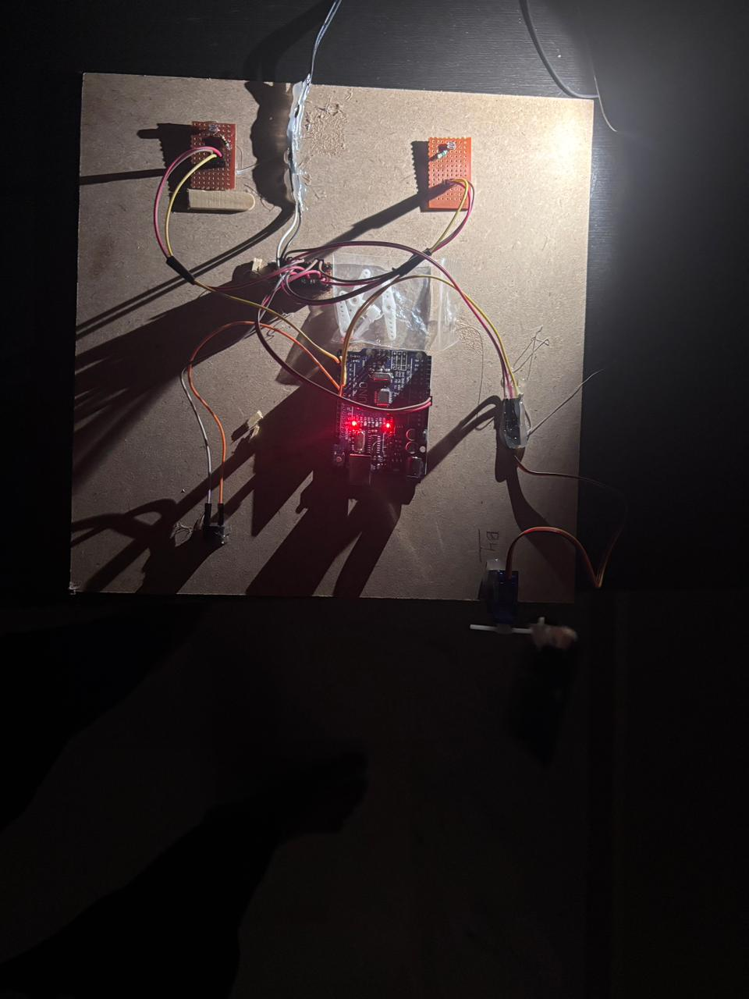

7.2 WORKING OUTPUT

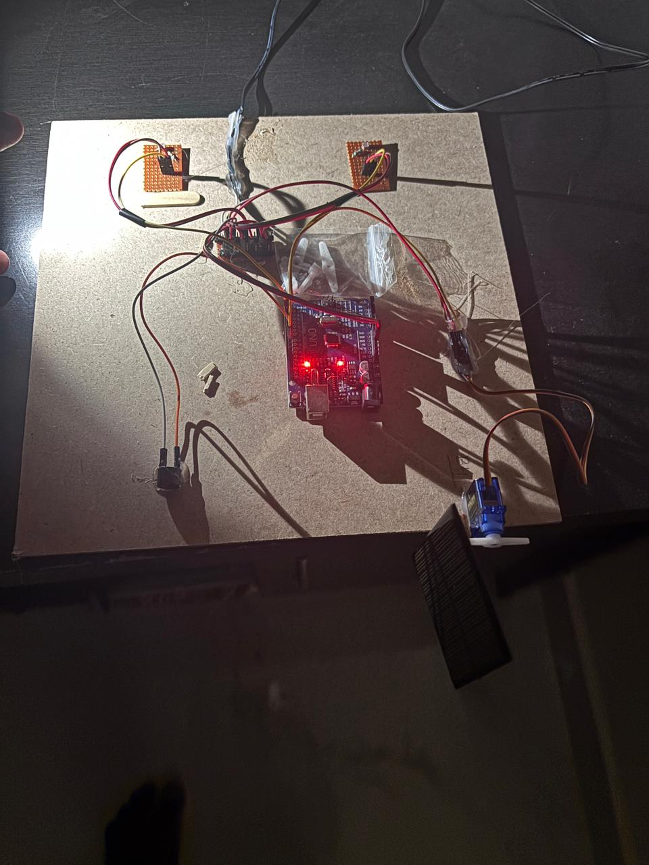

The Embedded Solar Tracking System was successfully tested under different lighting conditions. The system showed accurate detection of light intensity and proper movement of the solar panel based on sensor input.
In the first case, a flashlight was directed toward the right LDR sensor. The system detected higher light intensity on the right side. The Arduino UNO processed this data and rotated the servo motor toward the right, aligning the solar panel with the light source.
In the second case, the flashlight was directed toward the left LDR sensor. The system again responded correctly by detecting higher intensity on the left side. The controller rotated the servo motor toward the left, adjusting the panel position accordingly.
The results show that the system responds quickly to changes in light direction. The movement of the panel is smooth and stable, without unnecessary oscillations. The buzzer provides proper indication of system operation.
Overall, the system works efficiently and achieves automatic solar tracking. It successfully aligns the panel with the maximum light source, improving energy utilization compared to fixed panels.

8. CONCLUSION
The Embedded Solar Tracking System is designed to improve solar energy efficiency by automatically aligning the solar panel with the direction of maximum sunlight. This project shows how embedded systems and sensors can be used to enhance the performance of renewable energy systems. By continuously tracking sunlight, the system ensures better energy utilization compared to fixed panels.
The system is implemented using an Arduino UNO, LDR sensors, and a servo motor. The sensors detect light intensity, and the controller processes this data to determine the correct direction. The servo motor then rotates the panel accordingly. A buzzer is used to indicate system operation, making it easier to monitor.
Testing results show that the system works reliably under different lighting conditions. It responds quickly to changes in sunlight and maintains stable operation. The use of a threshold helps avoid unnecessary movement and ensures smooth panel rotation.
This project demonstrates how hardware and software can be combined to create an automated system. It also shows the practical use of embedded systems in renewable energy. The system can be further improved with features like dual-axis tracking or IoT-based monitoring.
In conclusion, the project provides a simple and effective solution for maximizing solar energy usage. It supports sustainable energy development and shows the potential of embedded systems in solving real-world problems.
9. FUTURE SCOPE
While the Embedded Solar Tracking System works effectively, it can be further improved to enhance performance and real-world usability.
Dual-Axis Tracking:
The system can be upgraded from single-axis to dual-axis tracking, allowing the panel to move both horizontally and vertically for better sunlight exposure and higher efficiency.
Energy Storage Integration:
Battery storage can be added to store generated energy, enabling power usage even when sunlight is not available.
IoT-Based Monitoring:
The system can be connected to IoT, allowing users to monitor and control it remotely through mobile or web applications.
Advanced Sensors:
More accurate sensors like photodiodes can replace LDRs to improve light detection and system performance.
Automatic Calibration:
The system can be enhanced with self-adjusting features to optimize performance under different conditions without manual changes.
Improved Mechanical Design:
A stronger and weather-resistant structure can be used to ensure durability and stable outdoor operation.

10. REFERENCES
Arduino Official Website: Documentation and resources for Arduino programming and hardware – https://www.arduino.cc
Servo Motor Datasheet: Technical specifications and working principles of servo motors used for panel rotation.
● LDR Sensor Basics: Information on Light Dependent Resistors and their application in light sensing systems.
● Embedded Systems Fundamentals: Study material and reference guides for microcontroller-based system design.
● Renewable Energy Resources: Information on solar energy systems and efficiency improvement techniques.
● Solar Tracking System Research Papers: Various research articles related to solar tracking mechanisms and performance analysis.
● Electronics Tutorials: Concepts related to sensors, actuators, and circuit design – https://www.electronics-tutorials.ws

